* FL/S Raw RQ Means

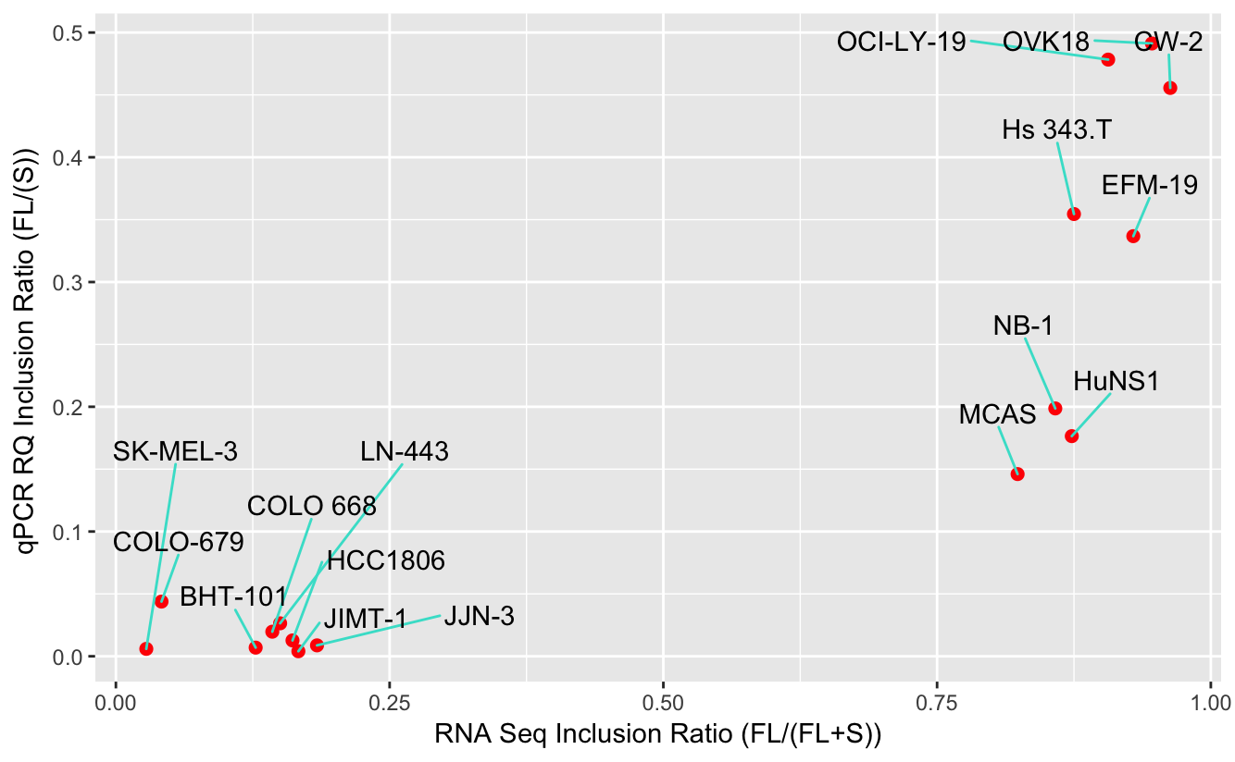

* Z-scored FL/S

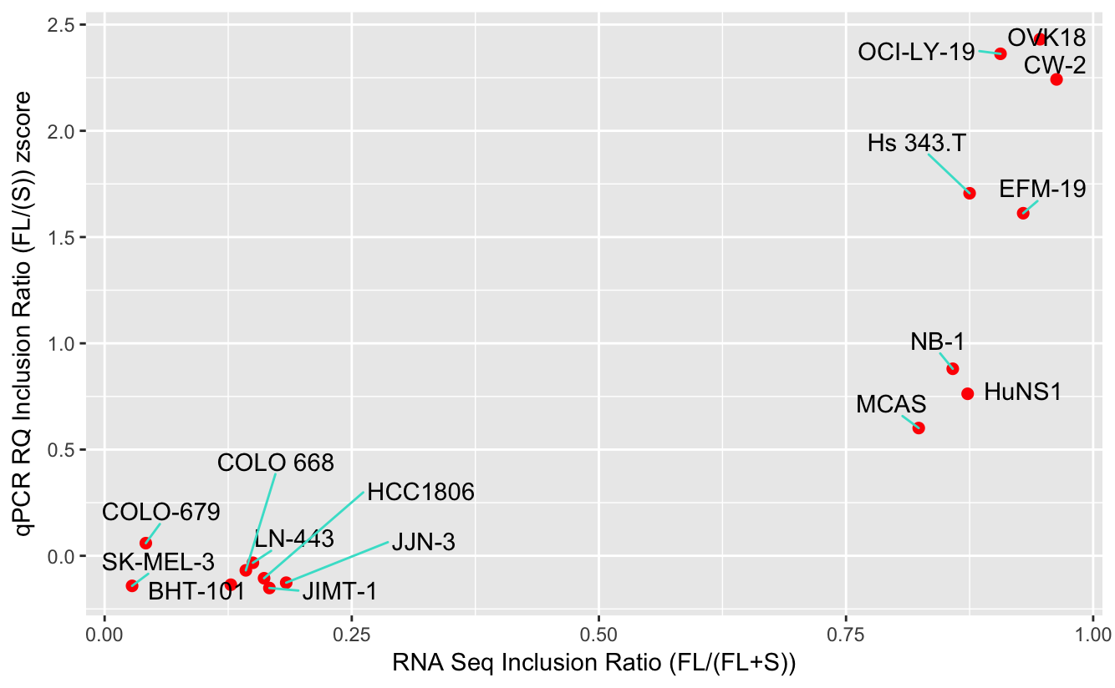

* FL/S RQ Means with SD



* FL / S plotted as Bar Graphs

